Project Acceptance
DOST STARBOOKS: Whiz Challenge

DOST Science and Technology Information Institute
Gen. Santos Ave., Upper Bicutan,
Taguig City, Metro Manila, 1631, Philippines

April 2026
Project Acceptance
STARBOOKS Whiz Challenge

This document establishes formal acceptance of all the deliverables for the STARBOOKS Whiz Challenge project. The STARBOOKS Whiz Challenge project has met all the acceptance criteria as defined in the requirements document and project scope statement. A project audit has been performed to verify that all deliverables meet performance and product requirements. Additionally a product evaluation has been performed and determined that all products meet the quality and functional requirements defined within this project.

Transition to Operations has been completed. The live system has been handed over to Operations and the transfer of knowledge from the Project Team to Operations has also been completed. All training has concluded and the System Operations Guide has been handed over to Operations.

The Project Manager is authorized to continue with the formal close out of this project. The closeout process will include a post-project review, documentation of lessons learned, release of the Project Team, close out all procurements and archive all relevant project documents. Once the closing process is completed the Project Sponsor will be notified and the Project Manager will then be released from the project.

Sponsor Acceptance

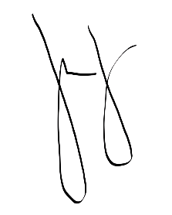
Approved by the Project Sponsor:

Date: May 22, 2026
Marievic V. Narquita

Information Services Section (ISS) Head of DOST-STII

